Project 1 – House Price Prediction
Task 1: Basic Data Exploration
1. Import necessary and essential libraries
Ans: import pandas as pd
import numpy as np
import matplotlib.pyplot as plt
import seaborn as sns

from sklearn.preprocessing import LabelEncoder

df = pd.read_excel('/content/HousePrediction.xlsx')
2. Display all the columns of DataFrame
Ans: df.columns
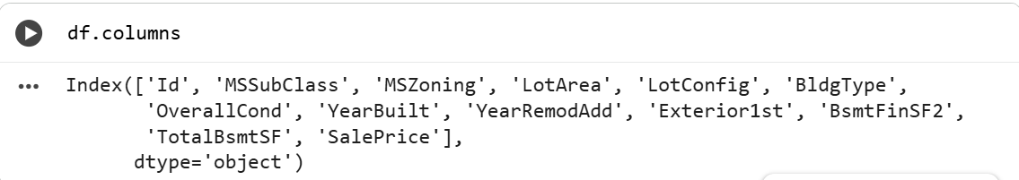
3. Read the data and display the first 100 rows
Ans: df.head(100)
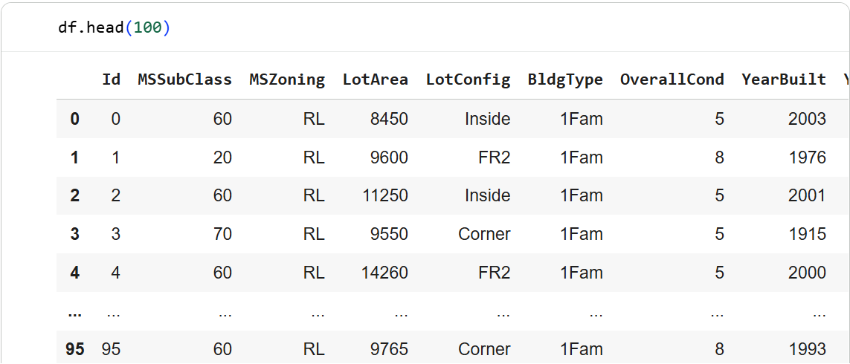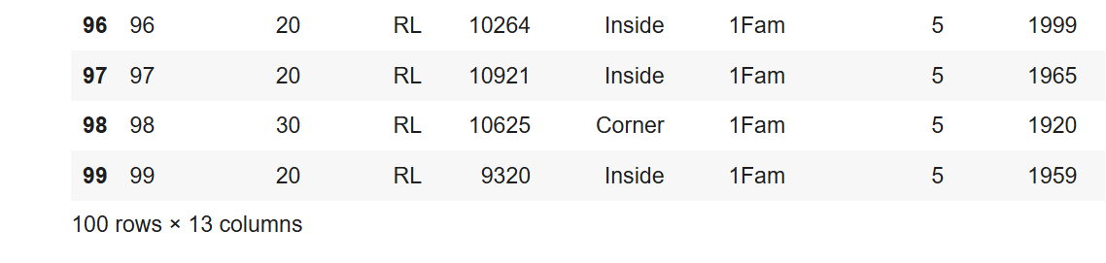
4. Give column insights
Ans: df.info()
df.describe()

Task 2: Data Cleaning and Analysis
Q1) Checking for Missing Values
Ans: df.isnull().sum()

Q2) Features with NAN Values
Ans: missing_features = [feature for feature in df.columns if df[feature].isnull().sum() > 0]
missing_features

Q3) Calculate Mean Sales Price for Missing/Present Information
Ans: for feature in missing_features:
print(feature)
print(df.groupby(df[feature].isnull())['SalePrice'].mean())
print('-'*40)
Q4) Count of Numerical Features
Ans: numerical_features = df.select_dtypes(exclude='object')
len(numerical_features.columns)
Q5) Print the First Five Rows of Numerical Values
Ans: numerical_features.head()

Q6) Compare the Difference Between Year Features and SalePrice
Ans: plt.scatter(df['YearBuilt'], df['SalePrice'])
plt.xlabel('YearBuilt')
plt.ylabel('SalePrice')
plt.show()

plt.scatter(df['YearRemodAdd'], df['SalePrice'])
plt.xlabel('YearRemodAdd')
plt.ylabel('SalePrice')
plt.show()

Q7) Relationship Between Discrete Variables and Sales Price
Ans: df.groupby('OverallCond')['SalePrice'].mean().plot(kind='bar')
plt.xlabel('Overall Condition')
plt.ylabel('Average SalePrice')
plt.show()

Q8) Relationship Between Continuous Variables and Sales Price
Ans: plt.scatter(df['LotArea'], df['SalePrice'])
plt.xlabel('LotArea')
plt.ylabel('SalePrice')
plt.show()

plt.scatter(df['TotalBsmtSF'], df['SalePrice'])
plt.xlabel('TotalBsmtSF')
plt.ylabel('SalePrice')
plt.show()

Q9) Histogram Analysis for Continuous Variables
Ans: df['LotArea'].hist(bins=30)
plt.xlabel('LotArea')
plt.show()

df['SalePrice'].hist(bins=30)
plt.xlabel('SalePrice')
plt.show()

Q10) Logarithmic Transformation
Ans: df['SalePrice_log'] = np.log(df['SalePrice'])
df['SalePrice_log'].hist(bins=30)
plt.show()

Task 3: Feature Engineering and Advanced Analysis
Q1) Find Outliers
Ans: sns.boxplot(x=df['SalePrice'])
plt.show()

Q2) Relationship Between Categorical Features and SalePrice
Ans: df.groupby('MSZoning')['SalePrice'].mean().sort_values().plot(kind='bar')
plt.show()

df.groupby('BldgType')['SalePrice'].mean().plot(kind='bar')
plt.show()

Q3) Correlation Between Numerical Features and SalePrice
Ans: corr = df.corr()['SalePrice'].sort_values(ascending=False)
corr

Q4) Continuous Features vs. SalePrice
Ans: sns.heatmap(df.corr(), cmap='coolwarm')
plt.show()

Q5) Feature Engineering

Ans: Handle Missing Values
df['LotArea'].fillna(df['LotArea'].mean(), inplace=True)
df['MSZoning'].fillna(df['MSZoning'].mode()[0], inplace=True)

Handle Categorical Variables
df = pd.get_dummies(df, drop_first=True)

Handle Temporal Variables
df['HouseAge'] = 2024 - df['YearBuilt']
df['RemodAge'] = 2024 - df['YearRemodAdd']

Advanced Questions for the Project:

Q11: How does the location (based on zoning and lot configuration) influence the house price?
Ans: df.groupby('LotConfig_Inside')['SalePrice'].mean()

Q12: What is the impact of the overall condition of the house on the sale price?
Ans: sns.boxplot(x='OverallCond', y='SalePrice', data=df)
plt.show()

Q13: Does the presence of a basement (based on TotalBsmtSF) significantly affect the house price?
Ans: df.groupby(df['TotalBsmtSF'] > 0)['SalePrice'].mean()

Q14: How do remodeling and renovations (YearRemodAdd) influence the property’s value over time?
Ans: plt.scatter(df['RemodAge'], df['SalePrice'])
plt.show()

Q15: Can we predict house prices using just categorical features (like building type, exterior material) without numerical features?
Ans: cat_features = df.select_dtypes(include='uint8')
cat_features.corrwith(df['SalePrice']).sort_values(ascending=False)

